User Requirements Story
FUNCTION | 008 MEMBER RATINGS
Description | - This module provides the ability for members to rate the service that they receive from other members  - The Member Rating will be similar to that which is offered by Uber, or eBay, where each transaction/interaction is rated  - The basic calculation of the rating will be NPS (Net Promoter Score)
Role: | - Member who either provided or received a product  - Only members that COMPLETE a transaction will be provided with an opportunity to rate the other member
I Want To: | - Member to complete a rating for buying/selling on VendeeX
So That I Can: | - Rate and promote Members as being reliable
Special Considerations: | - The rating calculation will be based on NPS  - We will ask the following questions  - How likely is it that you would recommend <member_X?> to a friend? [scale of 0-10]  - Please provide a comment about your experience of transacting with <member_X>  - How likely is it that you would recommend VendeeX to a friend? [scale of 0-10]
ACCETPANCE CRITERIA
Given: | - Member has completed a transaction to either buy or sell
When: | - After transaction has been completed  - Member is offered the opportunity to leave a rating, this is optional and can be skipped
Then: | - Member will be asked to Rate the transaction and the Other_Member involved in the transaction  - Member will be asked to leave a comment about the Other_Member  - Member will be asked to Rate VendeeX  - Ratings will be displayed next to Member_Profile  - Ratings can be seen by Member seeking to Buy or Sell with other Member  - Admin_Panel will provide an ability to “censor” comments that are inappropriate, and to block Members if necessary  - Ratings and Comments are not mandatory and can be skipped by member

Net Promoter Score is a customer loyalty metric created by Fred Reicheld, Bain & Company and Satmetrix in 2003. It is based on the perspective that every company’s customers can be placed within three types.

“Promoter” customers are enthusiastic and loyal, who continually buy from the company and ‘promote’ the company to their friends and family.

“Passive” customers are happy but can easily be tempted to leave by an attractive competitor deal. Passive customers may become promoters if you improve your product, service or customer experience.

Finally, “Detractor” customers are unhappy, feel mistreated and their experience is going to reduce the amount of which they purchase from you.
Detractor customers also have an increased likelihood of switching to a competitor as well as warning potential customers to stay away from your company.

In a nutshell, customers who give you a rating of 9 or 10 on a scale of 0 to 10 are considered Promoters. Customers who give you as rating of 7 or 8 are passive customers and whilst they are not dissatisfied, they do not factor into the NPS score. Lastly, any customers who provide you a rating of 6 or lower are considered your detractors.

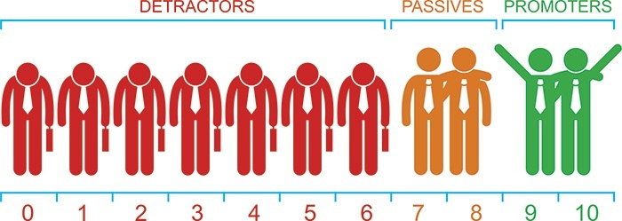

Your Net Promoter Score is calculated by subtracting the percentage of detractors from promoters to get an overall NPS result. Your Net Promoter Score can range anywhere from -100 to 100 and is always displayed as an integer.

To begin to determine and understand your Net Promoter Score, the ultimate NPS question must be asked to your customers:

“On a scale of zero-to-ten, how likely is it that you would recommend us (or this product/service/brand) to a friend or colleague?”

Respondents are asked to answer by using a 0 to 10 scale, where 5 is neutral. It is not only about asking for just a number and ending your survey. It is important to understand why each customer gave you their particular score as this will provide you with actionable items which can be targeted for effective process improvement or corrective action. This will also help you identify what your core strengths and competencies are.

